Challenges to develop the microservices:

1. Build the micro services
2. Sizing the micro services
3. Deployment, Portability and Scalability

2. **sizing the microservices**



i.e. microservices should not be so big that is cannot grab the whole advantages of microservices system, also it should not be so small or it should not have very less business logic due to which, we will end up having a greater number of microservices within organization. If onboard a greater number of small microservices then there will be operational overhead to make sure all these microservices are interconnected. That’s why its required to ensure that all microservices should have a proper size and their boundaries should be clearly define.

Solutions:

1. Doman driven sizing -> an application consists multiple domains or subdomains. To get a clear picture about the operations and services of a specific domain, its required to discuss with stakeholders, product owners, technical people, business analyst, QAs etc, then we can have some idea about the sizing of microservices. But this process is very time consuming.
2. Event storming sizing->

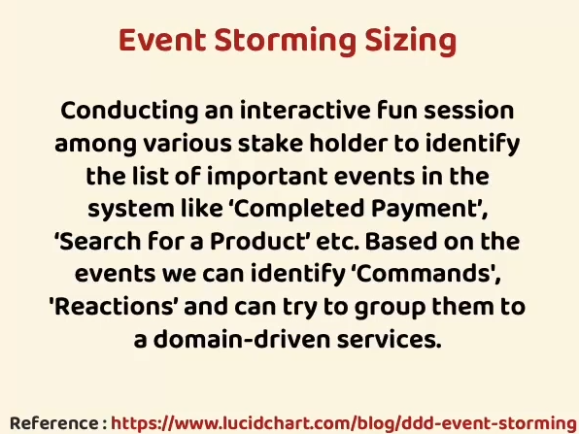

1. **Deployment, Portability and Scalability**->

**Portability means** how we can move 100s of microservices across environments with less effort, configuration and cost.

Container ->

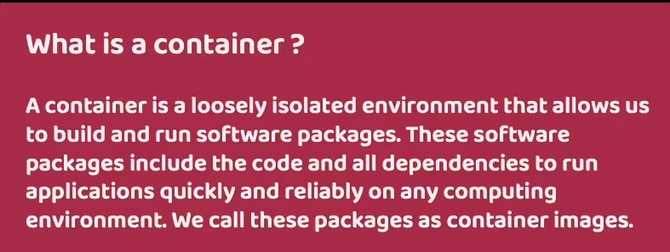

1. Docker commands to **create and running the container**:
2. Docker images
3. Docker run -p 8181:8080 <image_name >:tag , or

Docker run -p 8181:8080 <image_id>

The first port **8181** : the Docker host ( you can use this port to access to your container) to access to the container from the **outside**.

the second one **8080** : is the port used by your application (or where the running instance of application i.e. container is going to start)

**So after starting the container, we should use 8181 to access the application.**

**IMP-> We already start and exposed container on the Port 8181 of our system, therefor we can not reuse the same port for the start and running another container so we have to use another port of our system. And why don’t need to change the second port which is 8080 because this second port number indicates the port number where your container is going to start inside the docker network.**

1. Docker run -p 8181:8080 <image_name>:tag ,

here **p** indicates for port mapping, actually by default all docker containers starts running inside own isolated network, and we can not access the services inside their network therefor in order to get the access from external network like from local system or from any other system, we need to expose them explicitly with the help of this port mapping.

1. When container runs using below commands , no other docker commands can be run

Docker run -p 8181:8080 <image_name >:tag , or

Docker run -p 8181:8080 <image_id>

Therefor, to start containers in **detached mode** below command can be used

Docker run -d -p 8181:8080 <image_name>:tag , or

Docker run -d -p 8181:8080 <image_id>

**-d tells docker server that run the containers without display any logs on terminal.**

7. docker ps -> this command is using to **show all running containers**

8. running spring boot app as container using docker file

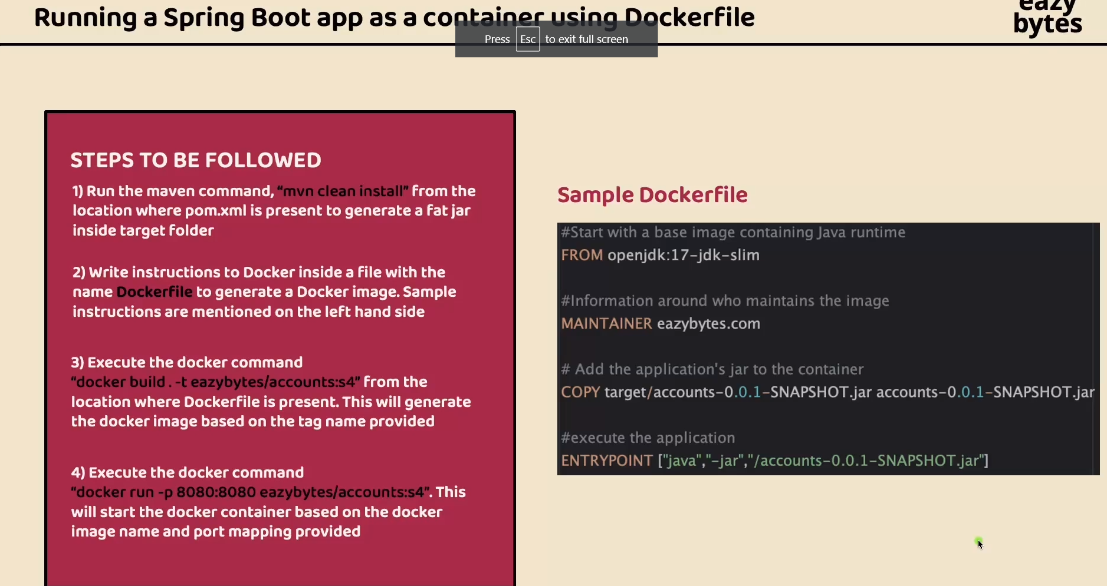

9. running spring boot app as container using buildpacks

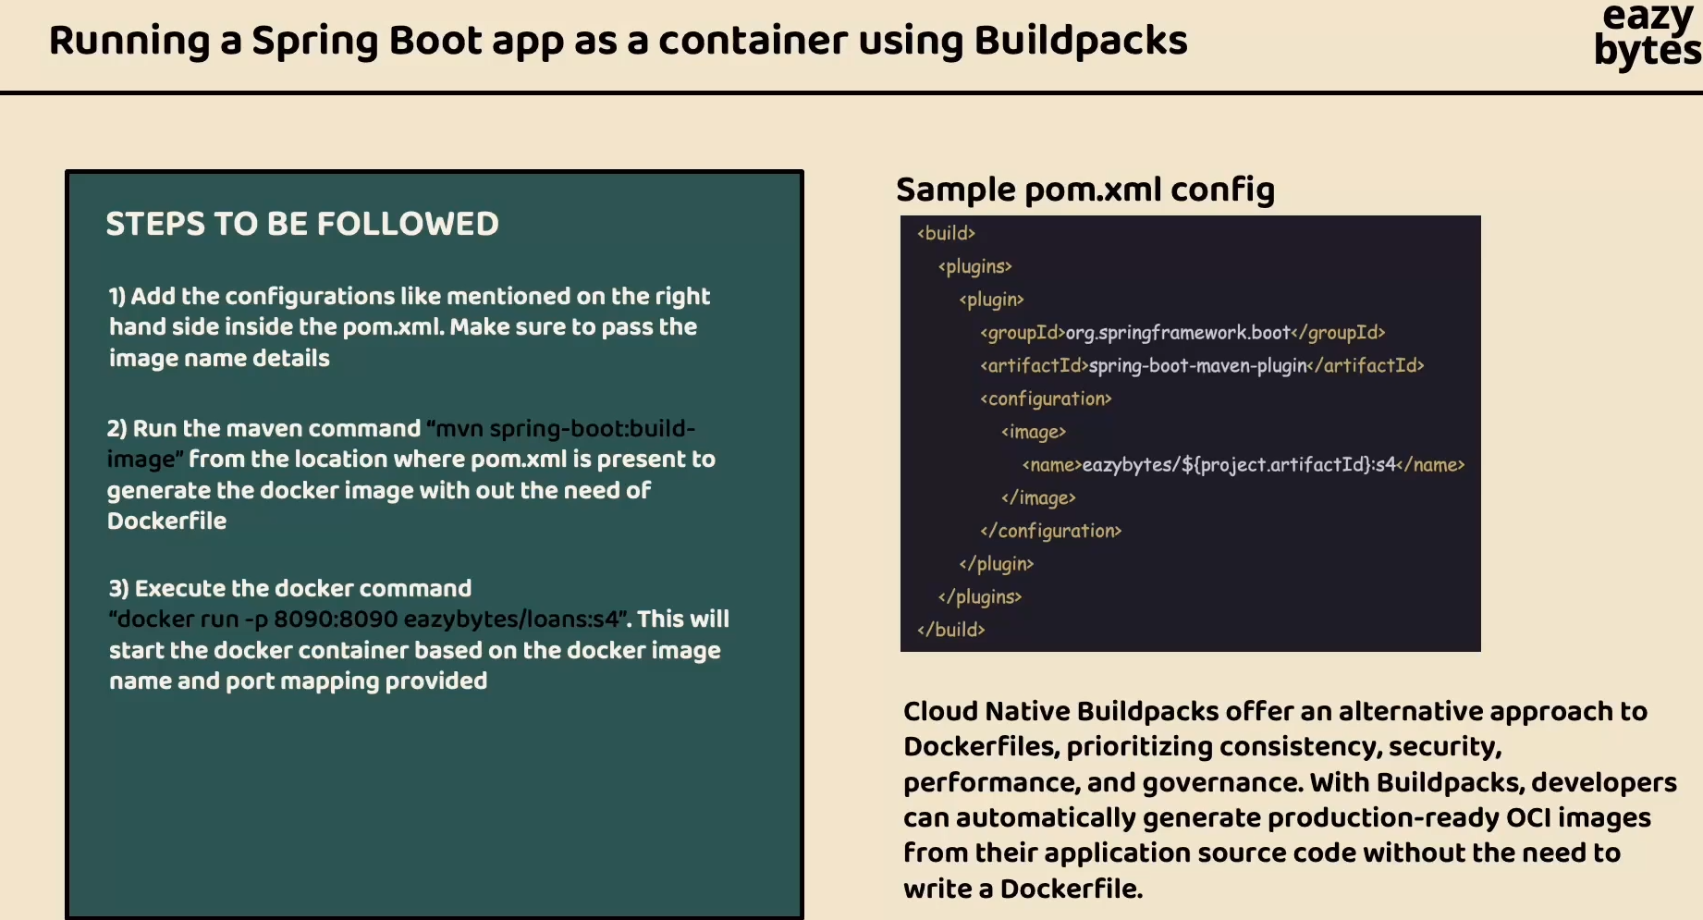

10. mvn spring-boot:build-image

Command to create docker image using buildpacks.

11. command to create docker image using google jib

mvn compile jib:dockerBuild

**a great advantages using google jib is we can create the Docker image even if we don’t have docker installed in our system**

12. running a spring boot app as a container using Google Jib

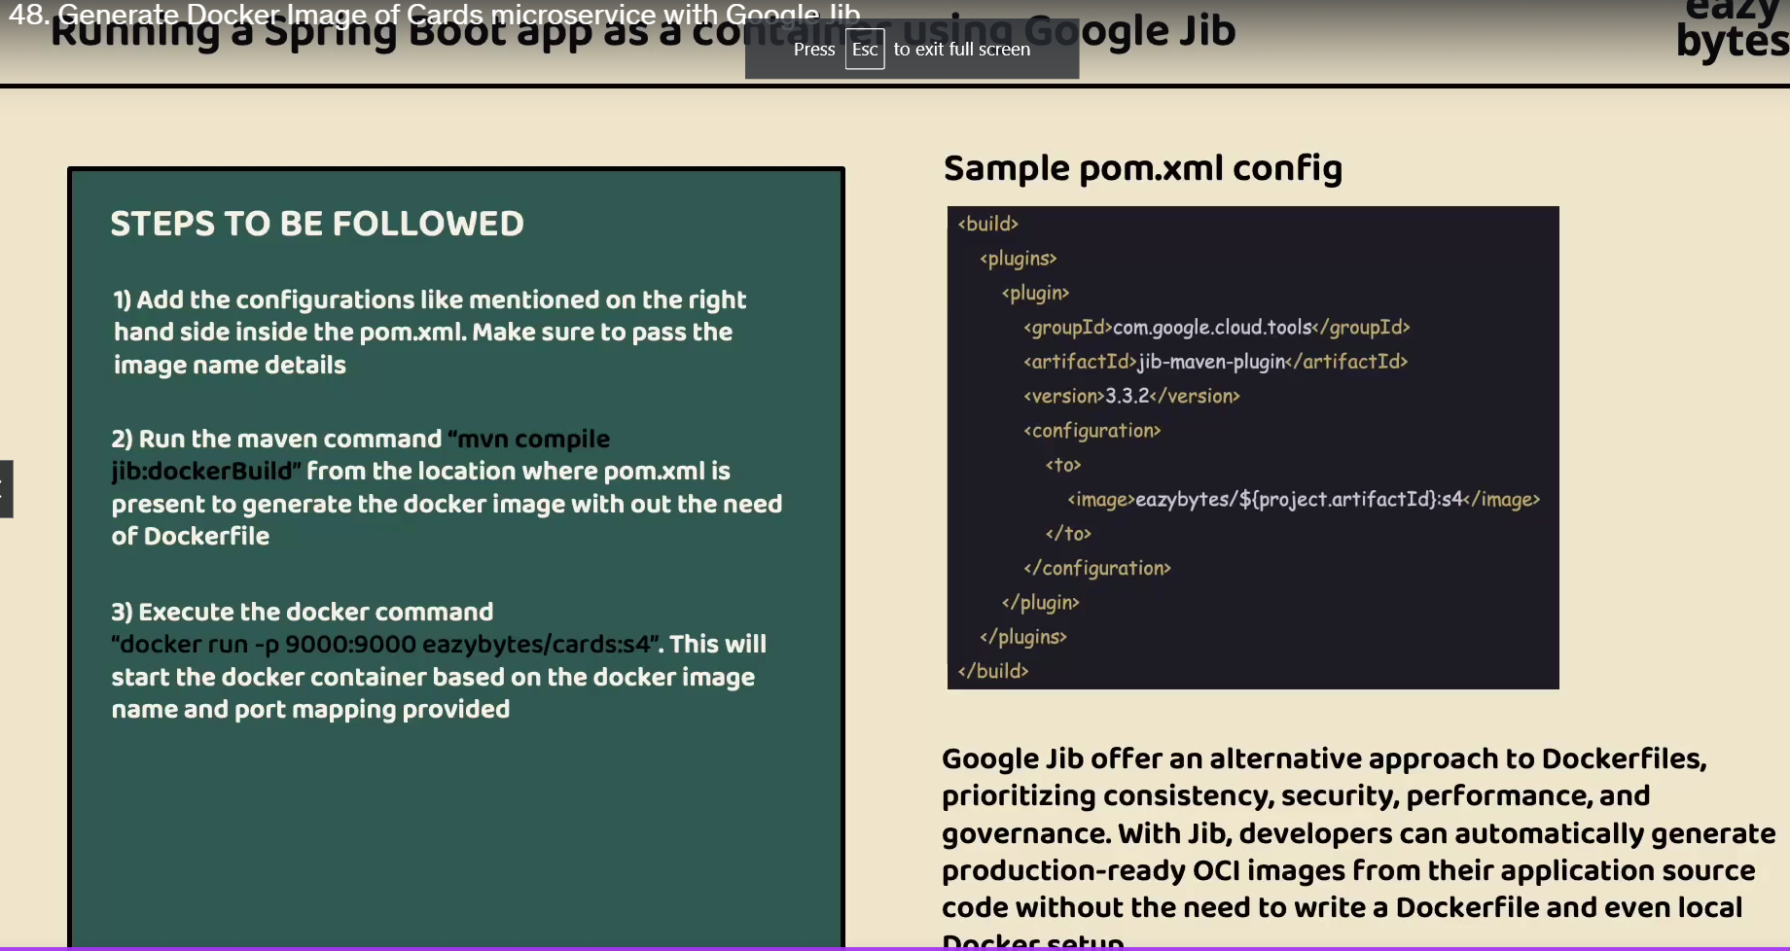

12. docker command for pushing the image into docker hub

docker image push docker.io/sandipnew/cards:s4

13. docker command to pull the card image from docker hub

docker pull sandipnew/cards:s4

14. comparison between docker file, buildpacks and google jib

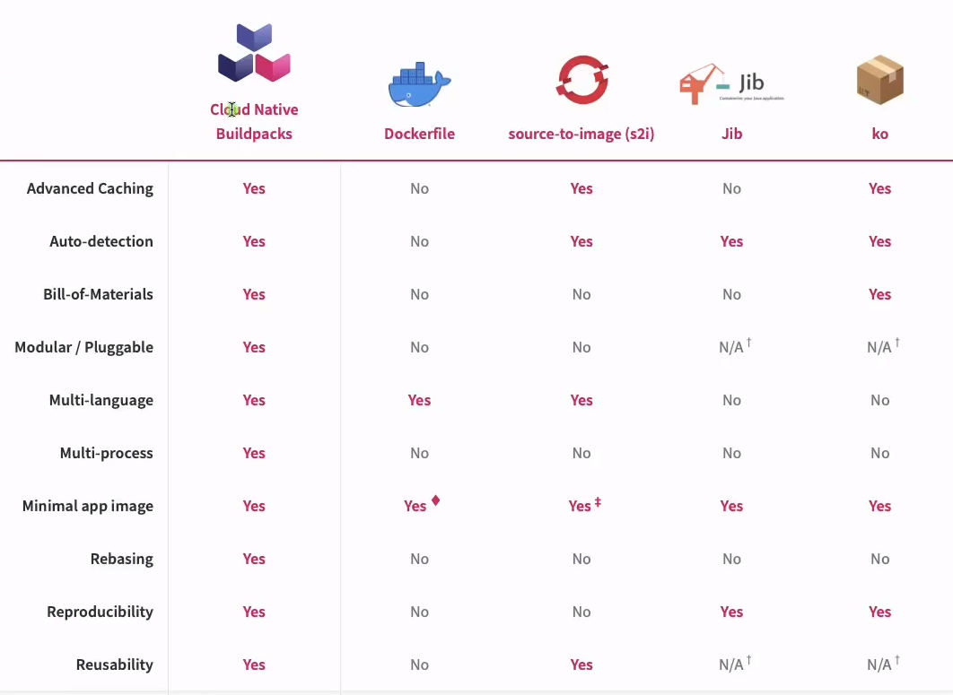

We have used google Jib to create docker image because

* It takes very less time to create docker image
* Takes less memory in local system
* We have created microservices in java only therefor used google jib(docker file and buildpacks are good while creating microservices in multi languages)
* **In Production its recommended to use buildpacks to create the docker images , infact Google Jib also works in Production but using Buildpacks is more advantageous as it supports advance features like Caching, multi-languages etc**

14. Docker compose –> it’s a tool for defining and running multi-container docker application. It uses a YAML file to configure applications services, then with a single command we can create and start all the services from configuration.

15. to start all the containers

* docker compose up -d

to stop and remove all containers

* docker compose down

to start the containers

* docker container start

to stop the container

docker container stop

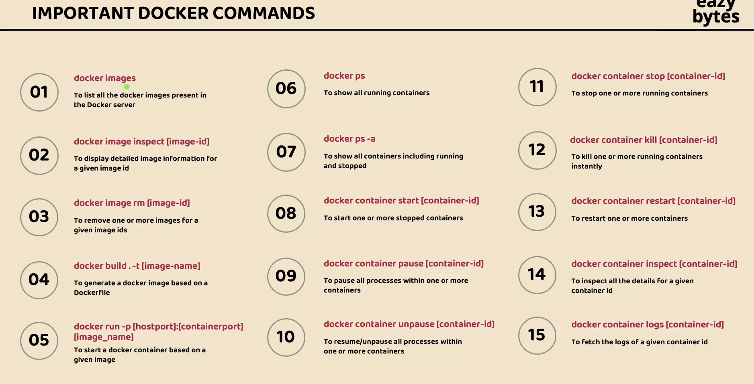

16.

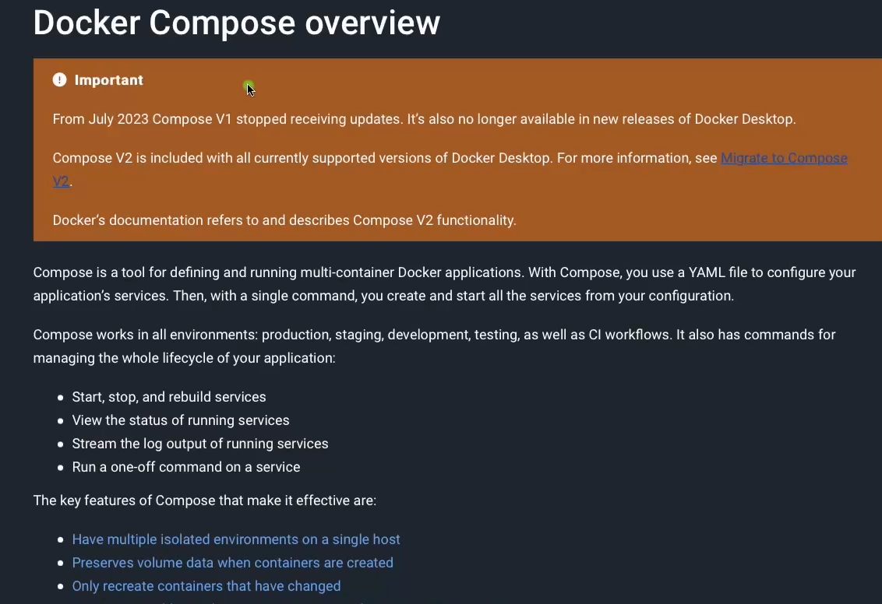

17. 15 factors app

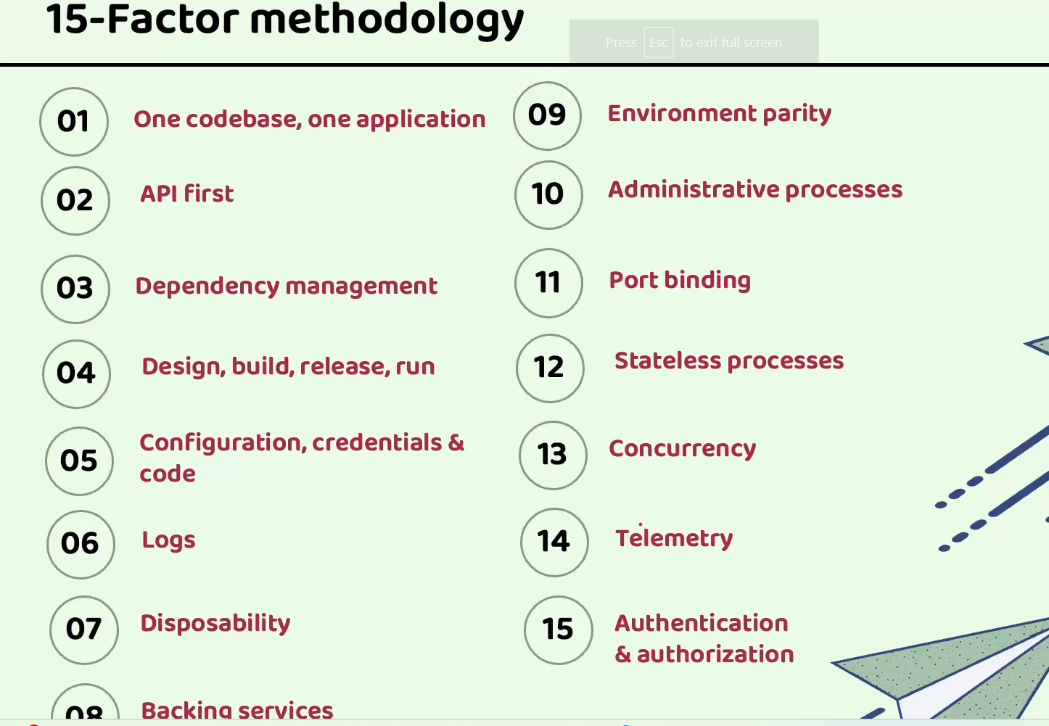

18. configuration management in microservices



19. 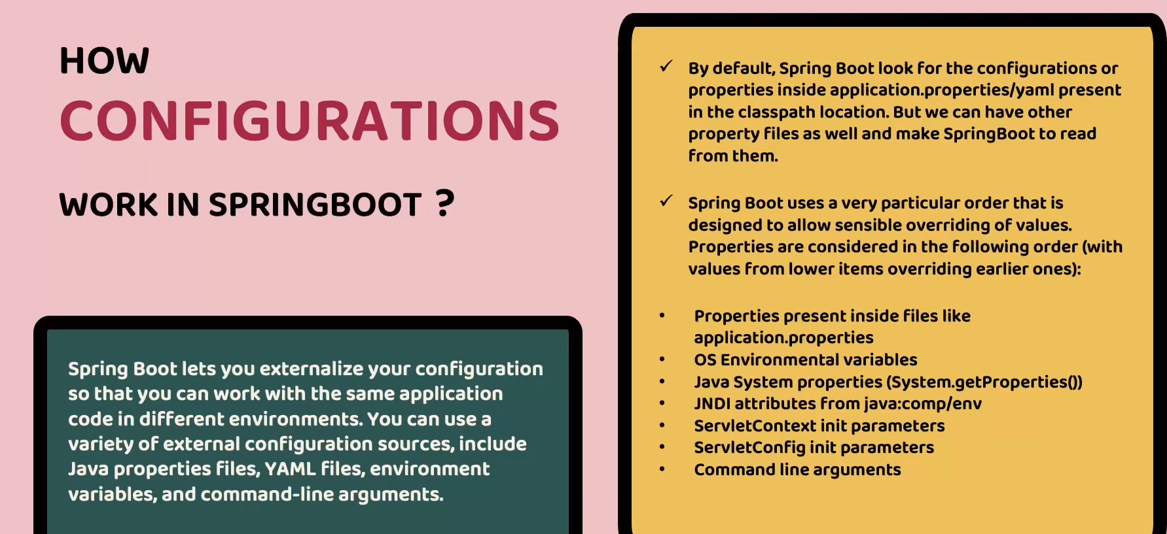

20.

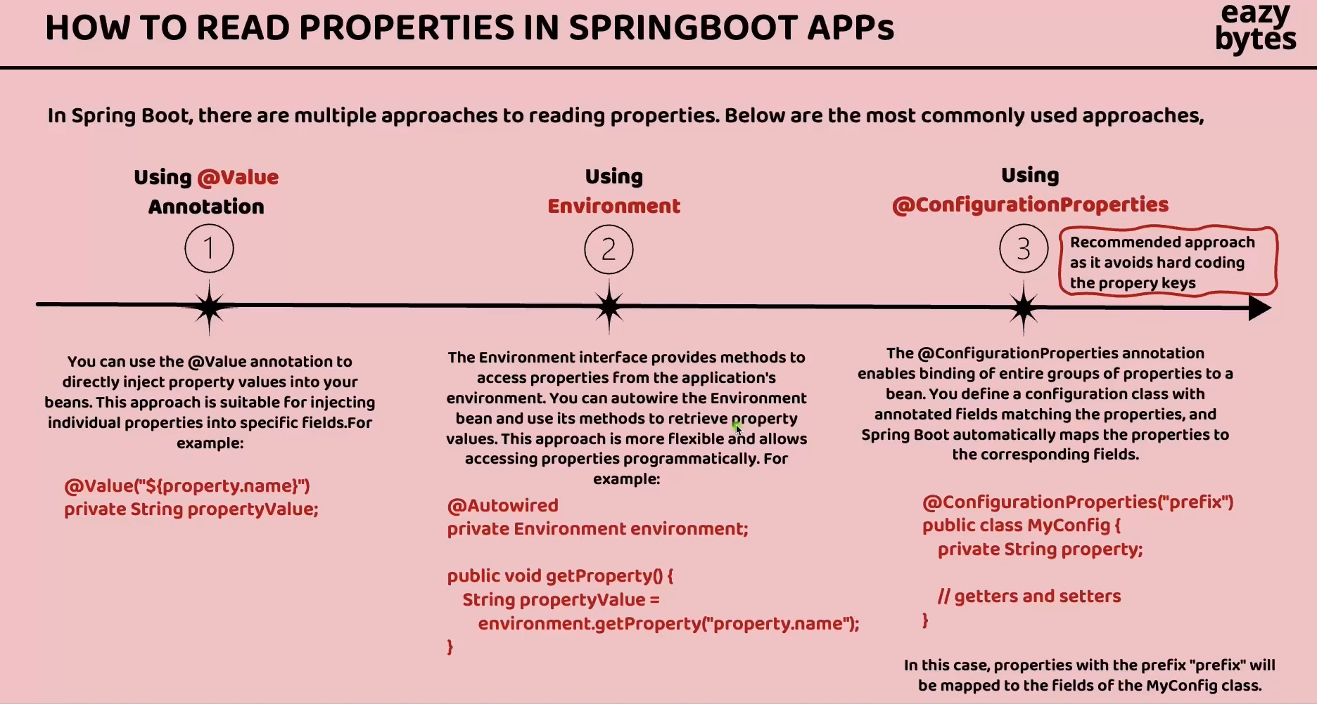

21. Spring Profiles

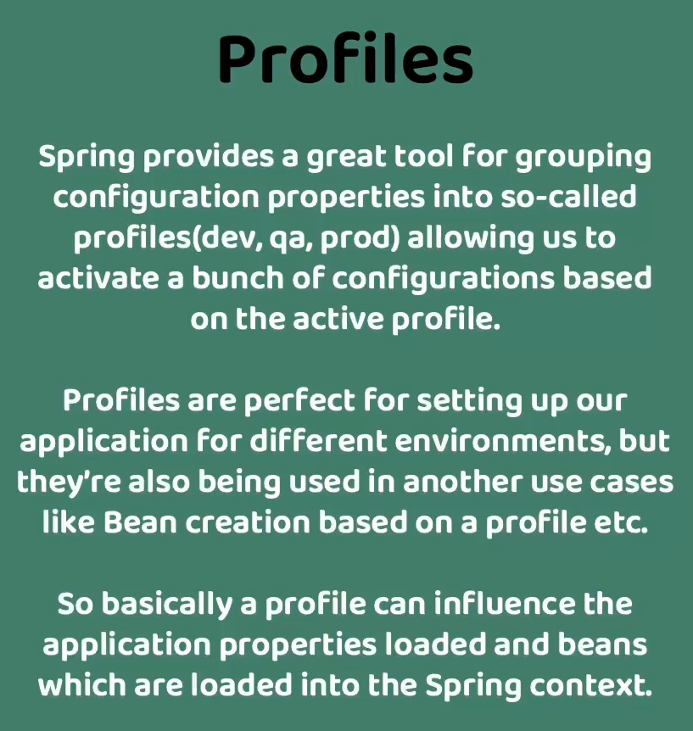

22. drawbacks of externalized configuration using Spring Boot Alone

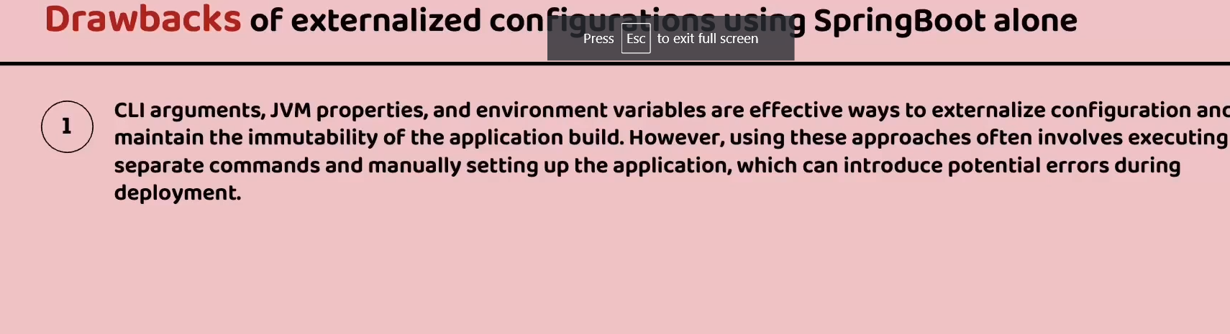

23. Difference between SOA and microservices architecture-

Both SOA and microservices architecture contains **independent and small services** still the differences are :

|  |  |
| --- | --- |
| SOA | Microservices |
| These services are not independent deployable. We would have large application which are built around services but if we have to them live, then we have to take entire application live | these services can be deployed independently |
| Entire business logic is written within heavy weight ESB and it might be single point of failure | Logic is written in each independent services |
| Centralized governed architecture | De-Centralized governed architecture |